**The rabbit hole – My role in the group- WEB14205**

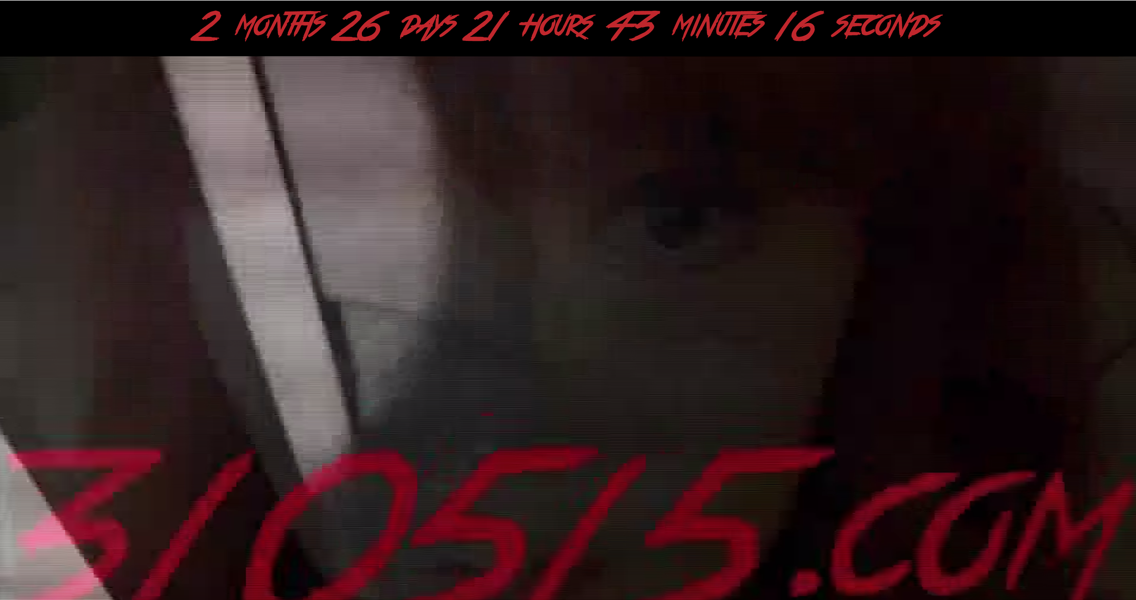This unit is all about creating an interactive narrative in groups of three. I'm working with Harry and Liam and together we came up with the idea that we are currently working on.

Our idea is all about our chosen characters going missing over the course of 5 months. The main character that is also a victim is blogging about these disappearances and the attributes that are linked to them.

The main tasks which I obtained throughout this project was to manage the twitter account of one of the main characters; Jojo. I made her interact with other users on twitter so that she’s was getting replies for the public to see, convincing them that she is a real person.

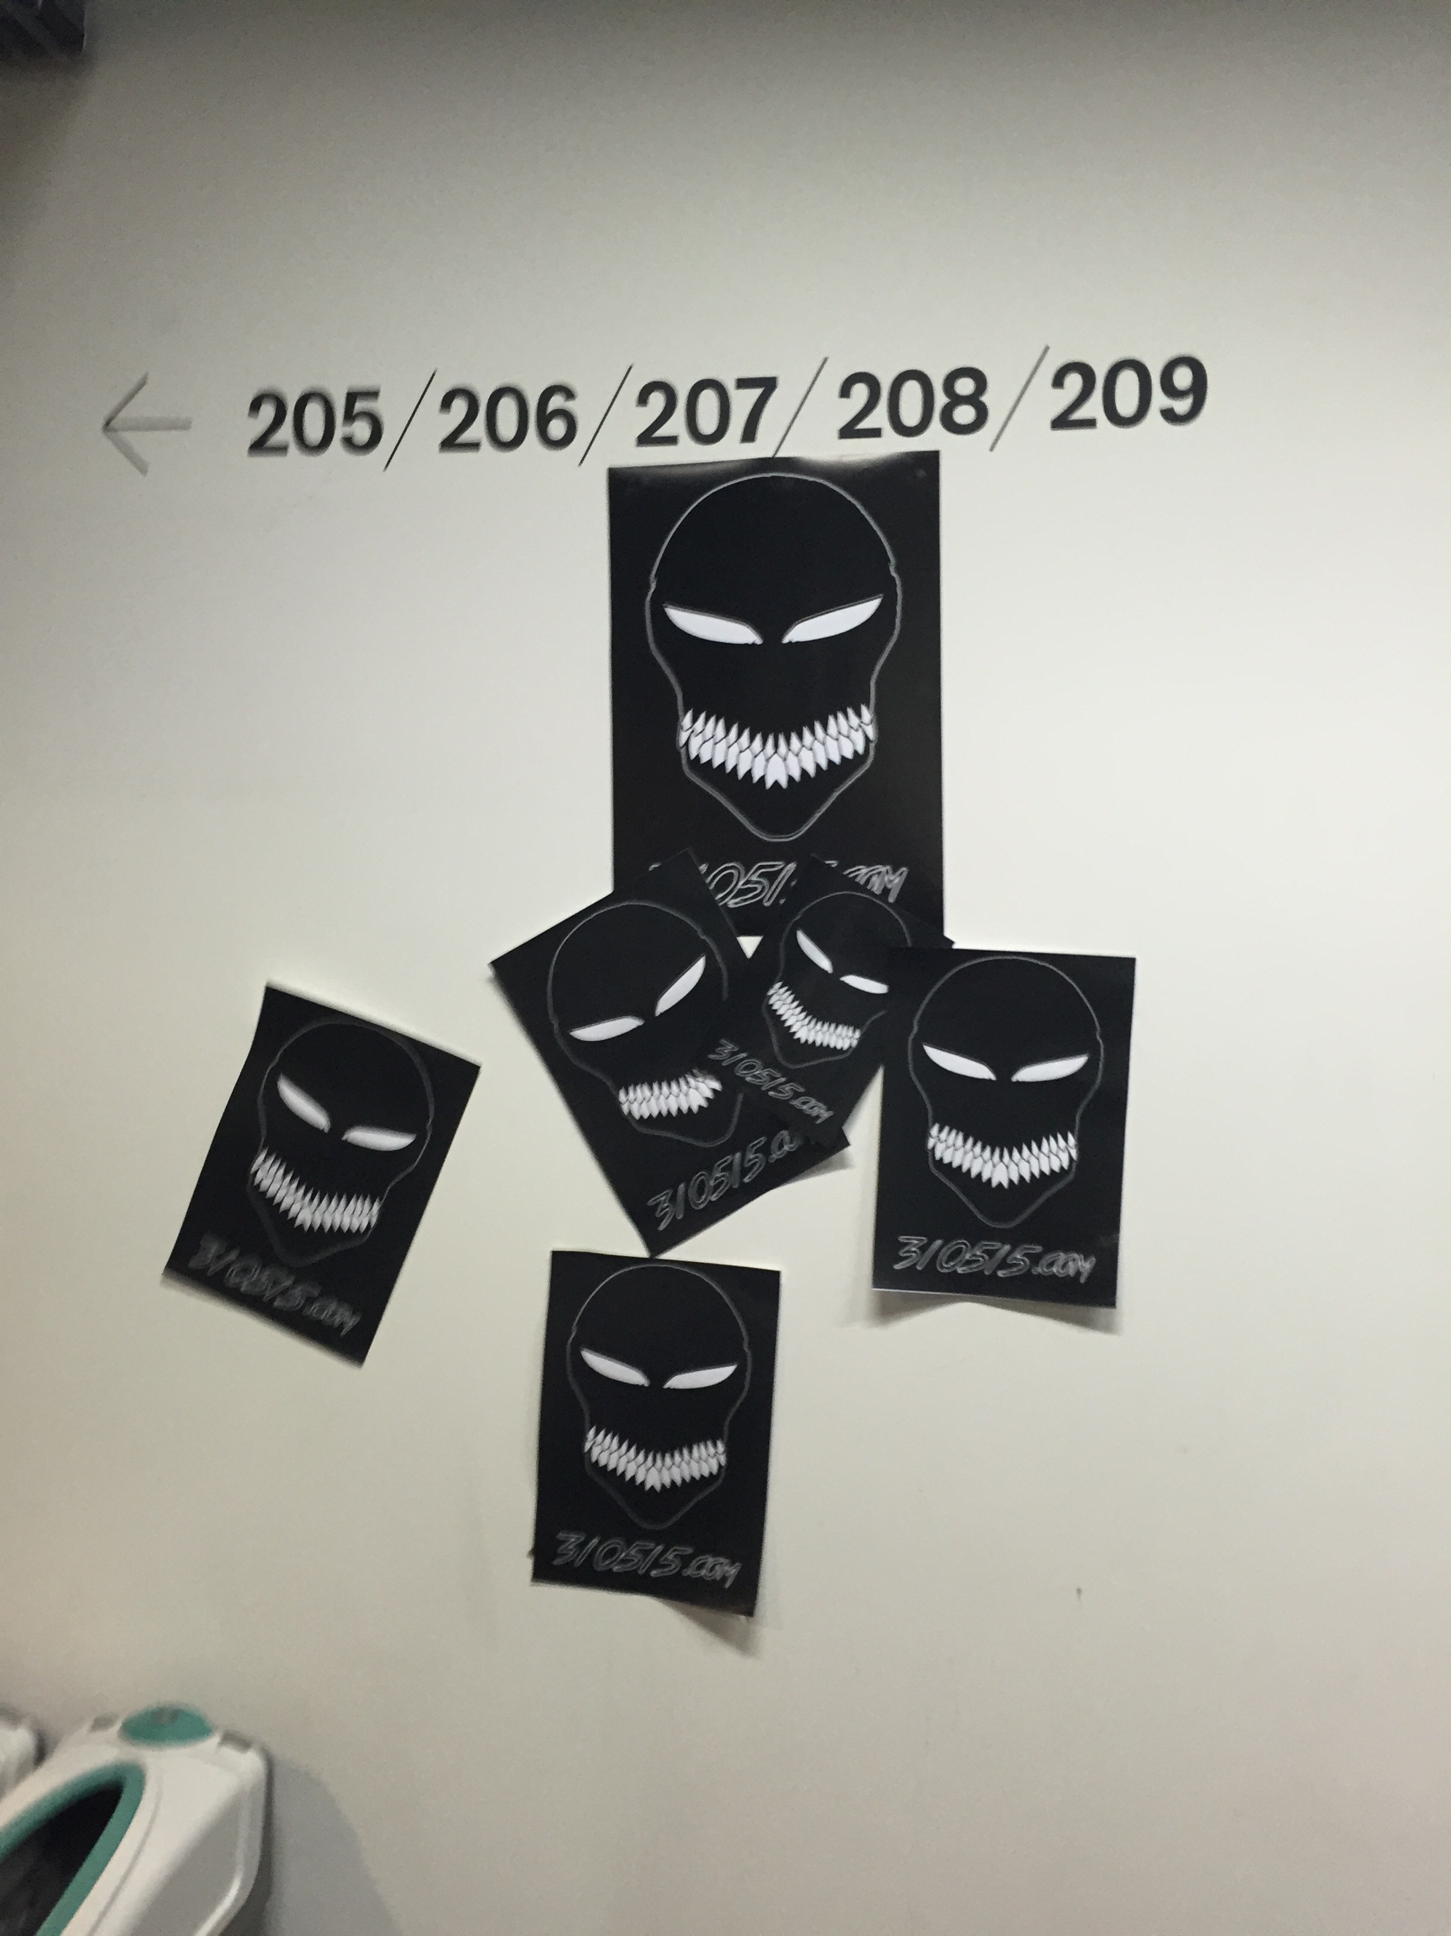 Then with the rest of my group I helped to formulate the idea, which we are currently working on. So we all gave in put into what we thought should happen and how the story should unfold. For example I put forward the idea behind how the real Jojo could find the rest of the victims. Also as a group we all went up and down all 9 floors of the university to stick up our iconography (the masks with the date on it).

I also had the job of creating the blog, and managing it. So this involved me picking and discussing possible dates with the rest of my group about what days Jojo should be blogging about particular events so that they corresponded with the videos, which were on the site.

As well as this I also set up the Google analytics for the site, so that we could start collecting data as fast as well could about our site, once one of our rabbit holes had gone live. But I just set it up but Harry managed it and make sure it was picking up everything we wanted to find out. I also constructed the formative and summative presentations.

Rabbit hole: [310515.com](http://310515.com)